Creating a permanent, formalised and visible system of connectors

About Community Connectors
Community Connectors are trusted, highly skilled community members who bridge the gap between families and systems, helping children and families in Logan navigate the “rough road” to equity. Connectors:
- Are deeply trusted and respected community members.
- Build bridges and smooth out transitions between systems and ‘hardly heard’ community members, beyond systems navigation.
- Identify needs, offer social prescriptions, and provide wraparound health and wellbeing supports within the culturally safe environment of Community Hubs.
Evidence shows Community Connectors effectively reach ‘hardly heard’ and marginalised families and deliver flexible, relational, localised support that improves access and outcomes. Logan has more than 30 Connectors working across 17 Community Hubs in Maternal and Child Health, Early Years, Child Development and Social Isolation.
Community connectors need to be located outside government institutions, as they risk losing their defining feature of being connected to the community if placed within institutions.
Logan’s Community Connectors work is sustained by supportive teams and hubs, strong relationships, and partnerships, but this alone is not enough to meet the complex needs of Logan’s families.

What are the challenges for Community Connectors?
Despite their critical role, Connector work is often invisible, under-resourced and dependent on unstable funding. Logan Connectors report that insecure funding affects staff retention and continuity of care, while limited time and resources constrain the support they can provide. Poor service integration makes referrals difficult. Research reflects these experiences: the role often remains unseen, evidence is largely qualitative, and stronger long-term evaluations are needed,. The intersectoral nature of the role also leads to unclear funding responsibilities—reinforcing the need for secure, sustainable funding outside government systems.
The lack of agreement regarding responsibility for funding Community Connectors given the nature of the role in crossing agencies would be overcome by secure and sustainable funding outside of government institutions.
How Logan Together is addressing these challenges
Logan Together are working alongside Community Connectors to create a permanent, formalised and visible System of Connectors. The System of Connectors will include:
- Mapping the essential elements of the System of Community Connectors model to ensure scalability and transferability nationwide.
- Establishing a Network for Connectors to strengthen collaboration and shared learning.
- Supporting capability development of Connectors through peer-to-peer learning, resource sharing, cultural support and learning opportunities.
- Building an enabling ecosystem that includes secure employment, professional and cultural supervision, sustainable workloads, and continuous professional learning.
- A learning approach that captures the practice wisdom of Connectors and shares it back with the network, the community hubs and with services and government to support systems change.
- Establish qualitative and quantitative processes for capturing data of the impact of Connectors.
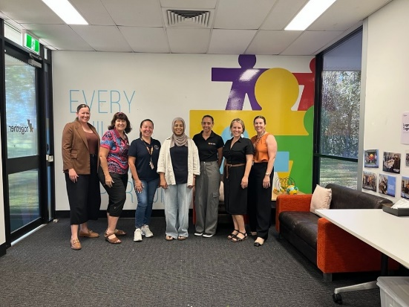
The Network for Connectors, co-designed with Community Connectors, will:

- Strengthen collaboration between Connectors and their organisations.
- Raise visibility and recognition of the Connector role
- Support information sharing and practice development
- Identify community trends to inform more responsive services and policy settings
- Provide a collective voice to advocate for systems change
- Strengthen evaluation processes around the impact of Community Connectors

Wallace C, Farmer J, McCosker A. Boundary spanning practices of community connectors for engaging 'hardly reached' people in health services. Soc Sci Med. 2019 Jul;232:366-373. Boundary spanning practices of community connectors for engaging 'hardly reached' people in health services - PubMed
Wallace C, Farmer J, McCosker A. Boundary spanning practices of community connectors for engaging 'hardly reached' people in health services. Soc Sci Med. 2019 Jul;232:366-373. Boundary spanning practices of community connectors for engaging 'hardly reached' people in health services - PubMed
Paul Ramsay Foundation. (2025). Understanding linkers: Challenges and potential. Paul Ramsay Foundation. https://www.paulramsayfoundation.org.au/news-resources/understanding-linkers-challenges-and-potential
Sharman, L. S., McNamara, N., Hayes, S., & Dingle, G. A. (2022). Social prescribing link workers—A qualitative Australian perspective. Health & Social Care in the Community, 30(6), e6376–e6385.
Calik, A., Liu, H. M., Montgomery, A., Honisett, S., Van Munster, K.-A., Morris, T., Eapen, V., Goldfeld, S., Hiscock, H., Eastwood, J., & Woolfenden, S. (2024). Moving from idea to reality: The barriers and enablers to implementing Child and Family Hubs policy into practice in NSW, Australia. Health Research Policy and Systems, 22, 83. https://doi.org/10.1186/s12961-024-01164-0)

